About Exciting Application
Exciting Application is a web based application for doing automated true ups. It features an app to node/server true up which will compare two source files to find missing app to node relationships which are only in one source files, apps which are listed in only one file, and app to node relationships which appear multiple times in one file. An app to node relationship is defined as the set of one app and one server which runs the app. An app or node may appear in multiple relationships as a server may run many apps and a app may be run on many servers.

Instructions
Exciting Application may be used to compare the app to node relationships in any two data sources such as the CMDB, Certification Portal or DataMart. You may perform the following steps to run a true up between the DataMart and CMDB.
- Obtain a report from the CMDB Browser. You must take care to ensure that the report is exported in .xls format. You may do this in the browsers reports tab. A report which details app to node relationship is located in the MDAS folder under the name vwAppToServer Original, or at the link: https://cmdbbrowser.btmna.com:8443/ucmdb-browser/?server=Default%20Client&locale=en#tab=reports~folders~b7e084e243d5e0d7ffe216bf446ed7f2;report=vwAppToServersOriginal

- To get a list of all app to node relationships from the DataMart you can run the following SQL statement in the DataMart and save the results into a .xls format excel sheet:
SELECT gsi_id, name FROM tbl_node tnode
INNER JOIN (SELECT tapps.btmu_gsi_sys_id AS gsi_id, tappnode.node_global_id
FROM tbl_businessapps tapps
INNER JOIN tbl_apptonode tappnode
ON tapps.global_id = tappnode.app_global_id) AS idtoapp
ON tnode.global_id = idtoapp.node_global_id
SELECT * FROM tbl_BusinessApps

- Next, navigate to https://usnj01dev436.ad.btmna.com:8099
- Use the form to fill out the information for each file. The following fields have the following requirements:
Choose File button: Use these buttons to upload the files you will be using for the true up.
Source 1/2 Name: This is the name which will be used in the true up results when referring to the file’s source. For the CMDB to DataMart True up we will enter CMDB for file 1 and DataMart for file 2.
Source 1/2 Sheet Name: This is the sheet in the excel file which contains the data for the true up. Reports from CMDB will always be in a sheet called “Report Results”. The default sheet name for a new excel document is “Sheet1”, so unless you changed it in step 2 it will remain the same.
GSI ID/Node Index: This is the index of the index of the column which contains the GSI ID or the Node. The columns are zero indexed, so column A translates to index 0, column C to index 2, etc. The indexes you enter must contain data or you will receive an error message. For the CMDB to DataMart true up we will use 1, 4 for file 1 and 0, 1 for DataMart.
This is how the form looks completely filled out for the CMDB to DataMart true up.
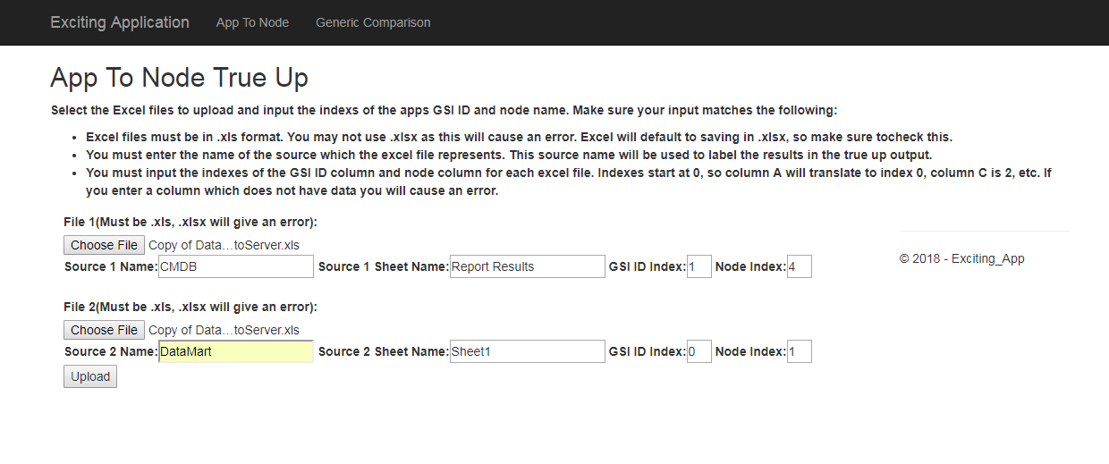
- Press the upload button to upload for processing. The results should look similar to this page: 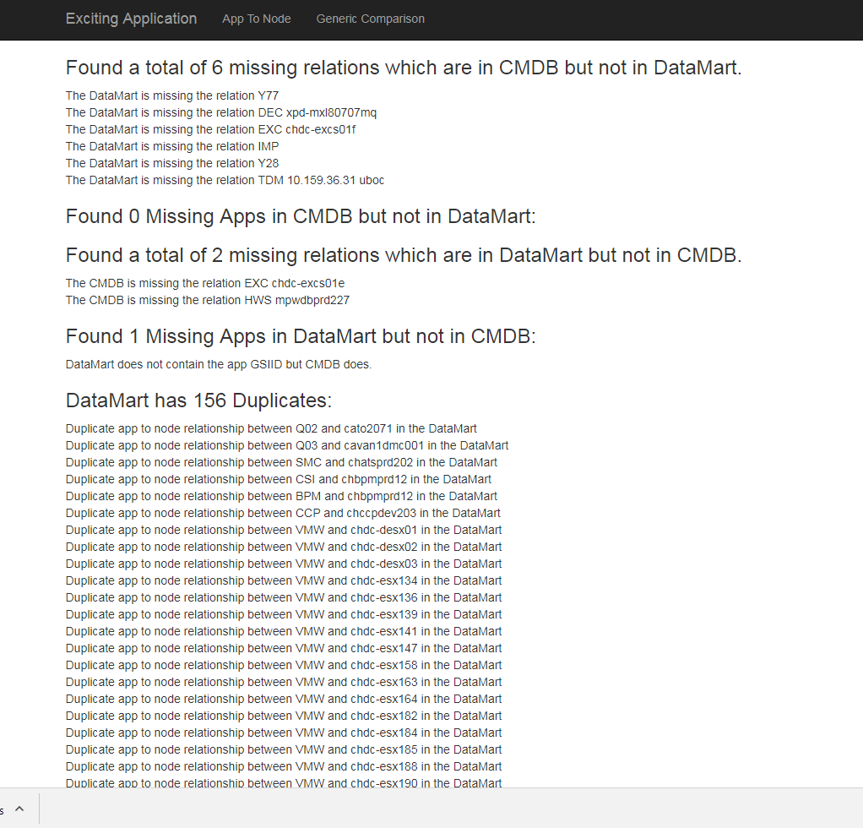

Error Troubleshooting
- Check that both files used are .xls and not .xlsx. This is the most common error. By default Microsoft Excel will save in the .xlsx format, and it is very easy to accidentally export a report in .xlsx instead of .xls. It is also possible you completely forgot to select a file.
- Ensure that the sheet names match the files exactly. They are case sensitive and even a small typo will cause an error. It is suggested to copy and paste from the file.
- The indexes selected must have data somewhere in the column. If there is no data in the column selected it will cause an error.

